Piece | No off | length | width | depth | Material
1 | 1 | 800mm | 300mm | 18mm | Pine shelf or furniture panel
2 | 1 | 500mm | 111mm | 45mm | Roundline guttering
3 | 2 |  |  |  | Roundline gutter bracket
4 | 2 | 260mm | 200mm |  | Large shelf bracket
JTT 2018
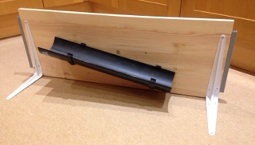
Working Drawing and Cutting List
100mm
200mm
60mm
110mm
150mm
3
4
4
3
2
1

