Roller Coaster Exploring Engineering Challenge
Instructions for Making Ramps and Stands

To make each stand, you will need:
Materials:
2x Part A pine 26 x 26x 350mm Uprights
1x Part B pine 20 x 100 x 250mm Base
1x Part C wooden dowel 6 x 300mm Horizontal rung (adjustable)
2x Part D 4x50mm length countersunk screws To attach base to uprights
Tools:
- Electric drill with 3.5mm, 4.5mm and 7mm drill bits plus countersinking drill bit
- Electric screwdriver
- Sandpaper

- Along each long edge of the uprights (part A) mark the centre line, 13mm from each edge (dotted line -------)

26mm
26mm
350mm

- Mark along this line, 6 points at 50mm intervals, which will be the drill holes.

- Using a 7mm drill bit, drill 6 holes completely through the baton, and check the 6mm dowel rod slides easily through the holes in the baton. Do for both batons so they are identical.

26mm
26mm
350mm
50mm

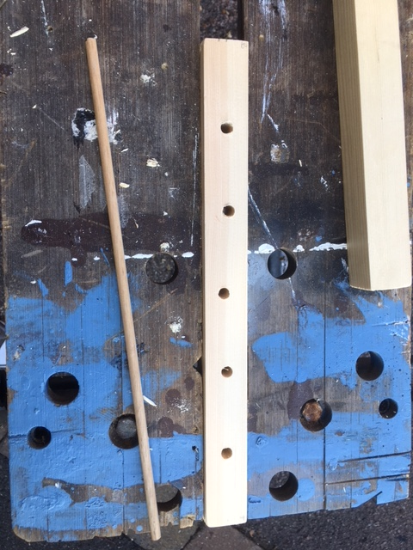
- In one end of each baton, mark the center point. The easiest way to do this is to draw diagonal lines from one corner to the other through the centre. Where they cross is the centre point.

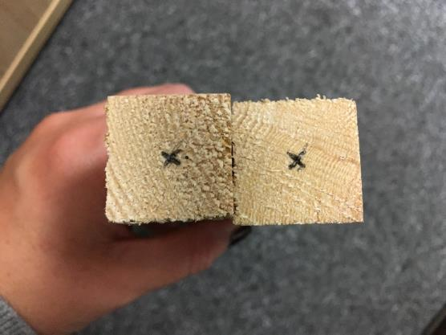

- Using a 3.5mm drill bit, predrill the end of the batons at the center point marked above.

- Take the base (part B) and mark out a point at each end, 13mm from the short edge and along the center line.
100mm
250mm
50mm
13mm
13mm
50mm

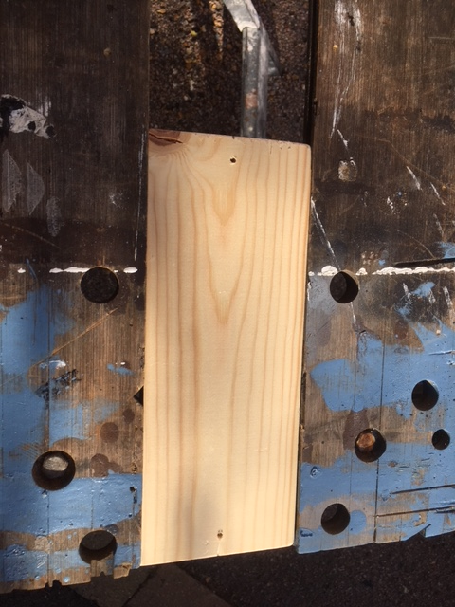
- Drill a hole through each mark, using a 4.5mm drill bit (so that the screw drops through it easily. Using a countersinking drill bit, drill one side, to create the counter sink, so that the crew heads sit flush within the wooden base.

- Sand off rough edges from all wooden parts.

- Using a clamp or workbench to hold the batons, use 2 screws (Part D) to affix the base to the wooden uprights, dropping the screw through the predrilled holes in the base (step 7) and using the guide holes in the ends of the batons (step 5). Ensure that the holes in the upright batons (7mm) run across the base (LR) so that a single dowel can be inserted through both uprights to give a “rung”.
Part B (base)
Part A (upright)
Part A (upright)
Part C (screws)

Holes going across

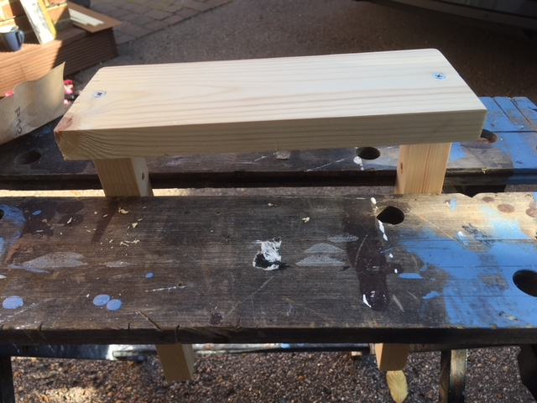

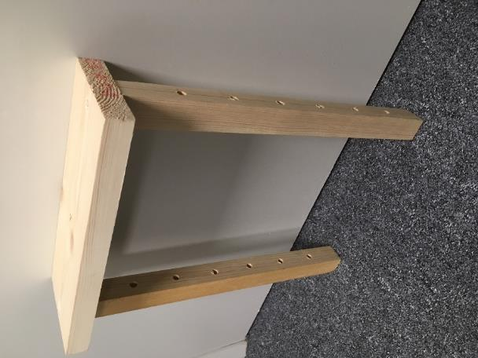

The stand should look like this when completed

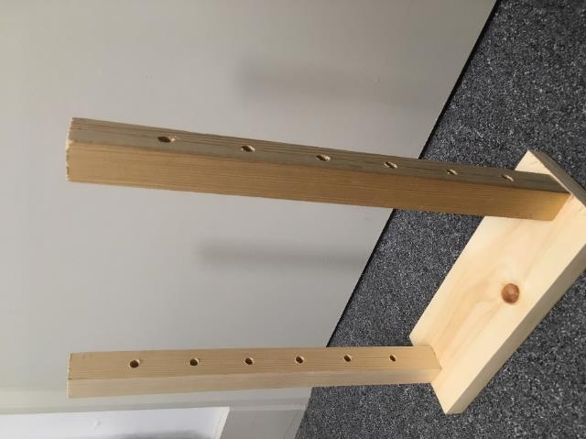

- Using secateurs or a tennon saw, cut the 6mm diameter dowel rod to length 350mm and sand rough edges.

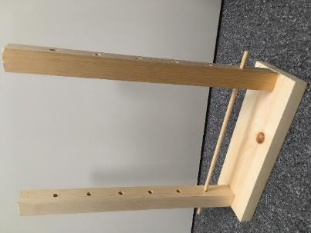
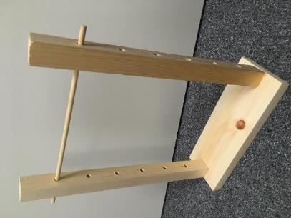
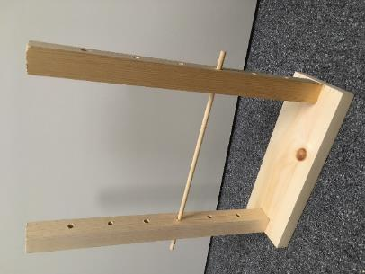
- The dowel should insert across the stand into the holes, at varying heights as shown below.

To make each ramp, you will need:
Materials:
1x Part E hardboard 3x185x640mm Ramp
4x Part F ‘Softwood Stripwood’ 8x20x300mm Long side batons
4x Part G ‘Softwood Stripwood’ 8x20x200mm Short side batons
12x Part H Panel pins 15mm length To join side batons to ramp

Tools:
- Hammer
- Sandpaper

- Measure a line, 265mm from one end of the ramp. This line will form the centre of a 10mm gap between the long batons and the short batons on each edge and each surface of the ramp.
265mm
Part E (Ramp)

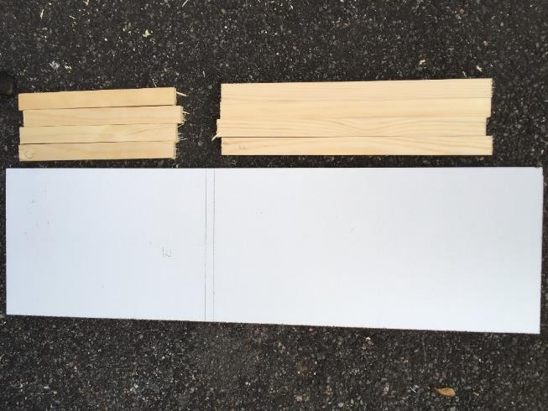

Each ramp will now have a short end and a long end.

- On the “long end” lay one long (300mm) baton (part F) underneath the ramp, with its end 5mm from the marked line. Lay another long (300mm) baton on the top surface of the ramp, in line with the other baton. Both baton ends should be 5mm from the marked line. The batons should be 70mm from the end of the ramp.
265mm
Marked line
Part E (Ramp)
Part F (long baton)
Part F (long baton)

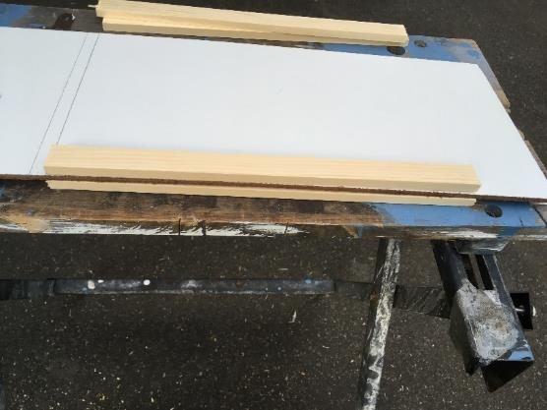

- Using 3 panel pins (2 going through from one side and one from the other), secure the batons to the ramp. The panel pins should go through the baton and hardboard and into the baton on the other side, without the end of the pin going all the way through.

Marked line
Part F (long baton)
Part F (long baton)
Part H (panel pin)
Part H (panel pin)
Part H (panel pin)

- This should be repeated with the other pair of long batons (part F), along the opposite edge of the ramp.

265mm
Part E (Ramp)

- Repeat steps 2-4 for the short (200mm batons) at the short end of the ramp. This should give a 10mm gap between the long and short batons.

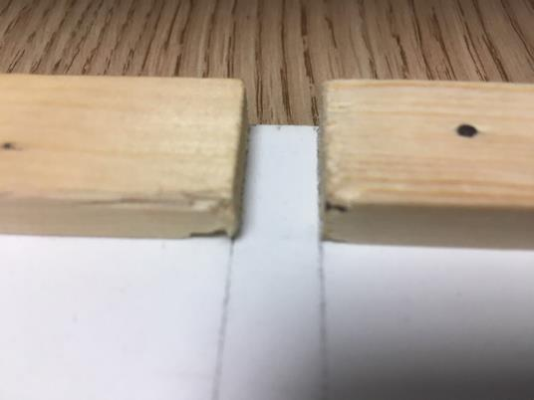

The short batons should be 60mm from the end of the ramp.
- Once all batons are attached to the ramp, both surfaces should have 2 long and 2 short batons on them as shown below.

265mm
Part E (Ramp)

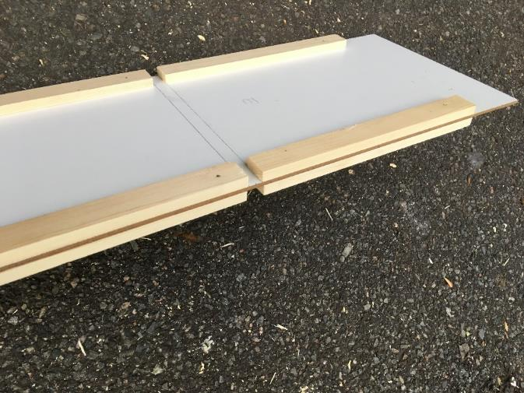

The final ramp and stand should look like this. The short end goes at the top of the ramp, so that it doesn’t tip backwards.

